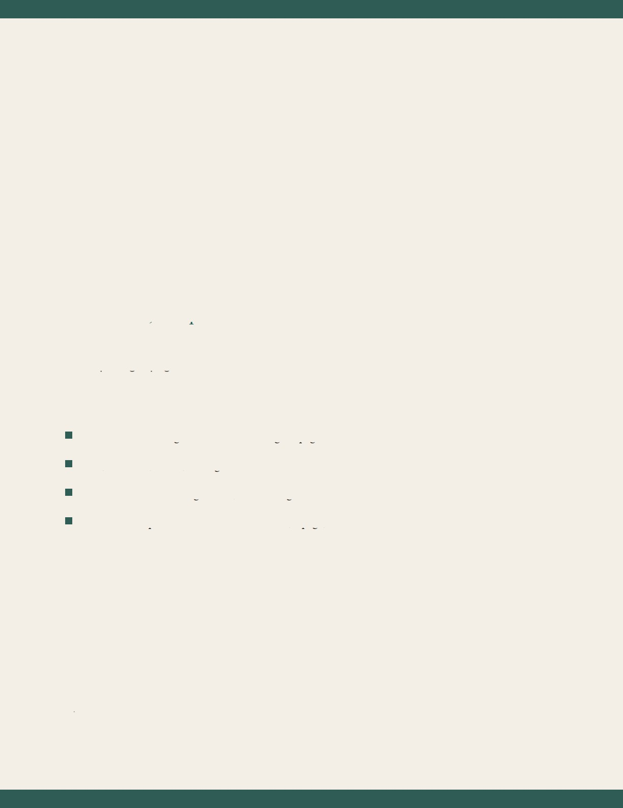
FOLIOSYNE
Documents, composed.
A sample eight-page document for the in-browser studio.
Read and search long PDFs without leaving the page.
Edit, comment, redact, and sign — then save a real PDF.
Convert to Word or Google Docs, and back again.
Protect with a password. Translate a selection, a page, or the file.
Open · Annotate · Convert · Share


Reading & navigation
Foliosyne renders pages on demand, so a long report does not stall the studio. Use the zoom controls,
fit-width, and fit-page. Page Up and Page Down walk the document; the page stack in the rail jumps to a
leaf immediately.
Move a page up or down in the stack when the order is wrong. Rotate a single page, a typed range such
as 2-5, 9, or the whole file — ninety degrees at a time, or one hundred eighty.
When the pointer rests on words, it becomes a text-selection cursor. Drag to copy. Nothing extra to
switch on.
Foliosyne · Studio guide 2 / 8


Editing, comments, signatures
Add text boxes where the original layout needs a correction. Highlight a passage. Drop a comment pin
and write the note — every comment also lives in the side rail.
Signatures come three ways: typed full name, typed initials, or a photograph of a real signature in JPG,
PNG, or WebP. White paper behind a photo is knocked out so the ink sits on the page. Save a signature
once, stamp it on any page.
Marks stay on the document until you save. Saving bakes them into a new PDF you can download, print,
or share.
Foliosyne · Studio guide 3 / 8


Protect, redact, convert
Set an open password. Foliosyne encrypts the file with AES-256 when you save, so the next reader must
know the phrase.
Redaction is a drag rectangle. On export the cover is opaque, and redacted runs are omitted from Word,
Google Docs, and translation so the hidden words do not leak through a conversion.
Convert a PDF to Word for further drafting, or to Google Docs via a .docx plus formatted HTML you
can paste. Word files and Google Docs exports (.docx) convert the other way — into a clean PDF you
can sign and protect.
Foliosyne · Studio guide 4 / 8

Translate & cloud
Choose a target language, then convert the current selection, this page, or the whole document. Place the
translation as a text box, or copy it.
The interface itself has a language menu in the top bar: every label, tooltip, and help dialogue follows
that choice, including right-to-left Arabic.
Share downloads the file, uses the system share sheet when the browser allows it, or sends you toward
Drive, Dropbox, Box, OneDrive, and iCloud. Printers discovered on this Wi-Fi appear in the system print
dialog — save Home and Work labels so the destination is obvious.
Foliosyne · Studio guide 5 / 8


Bookmarks & large files
Detect section headings automatically, or pin a custom placeholder on the page you are looking at. Click
a bookmark to travel. Outlines already inside a PDF are imported when the file opens.
Thumbnails on the left keep place in a long deck. Only pages near the viewport are painted, so a
hundred-leaf contract stays responsive.
Light is the default paper. Dark mode inverts the chrome, not the page ink, so proofs stay readable at
night.
Foliosyne · Studio guide 6 / 8


Keyboard shortcuts
Ctrl or Cmd with O opens a file. S saves a PDF. P prints. Plus and minus zoom; 0 fits the width. Page Up
and Page Down turn leaves. Escape closes a panel or cancels a drawing tool. Delete removes the selected
mark.
Hover any tool for a short explanation. The Help panel repeats this map in the language you chose.
This sample is itself a PDF generated in the studio — save it, sign it, redact a line, translate a paragraph,
and convert it to Word to confirm the round trip.
Foliosyne · Studio guide 7 / 8


Colophon
Foliosyne is an editorial name: folio, a leaf of paper; syne, together. It is not Adobe, not Acrobat, and not
a cloud locker pretending to be a reader.
Work stays in this browser until you export. There is no account wall on the studio floor. Drive import
uses the Drive already connected to the Grok session when that grant exists.
Print through the operating system so home and office printers on Wi-Fi — AirPrint, IPP, shared queues
— are the ones you already trust.
Set a language. Set a mode. Open something that matters.
Foliosyne
Foliosyne · Studio guide 8 / 8

